Jordan Dubreil
IST 652 Scripting

Entertainment Industry Trends Analysis Using MovieLens, Netflix, and IMDb Data

Introduction
This project analyzes trends in the entertainment industry using data from three major sources: MovieLens, Netflix, and IMDb. The goal is to compare genre distribution, audience ratings, and content production over time across these platforms. By combining multiple datasets, this analysis provides insight into how different platforms represent and evaluate entertainment content. MovieLens offers user-generated ratings across a wide range of films, IMDb reflects curated and highly rated films, and Netflix represents modern streaming content. The project focuses on three key research questions: identifying the most common genres across platforms, comparing average ratings by genre, and analyzing how content production has evolved over time.
Data Description
Three datasets were used in this project. The MovieLens dataset contains movie titles, genres, and user-generated ratings. The Netflix dataset includes information on titles available on the platform, including release year, content type, and genre categories. The IMDb dataset contains highly rated films along with their genres and ratings. These datasets were chosen to provide different perspectives on entertainment content: user-driven ratings (MovieLens), curated high-quality films (IMDb), and modern streaming content (Netflix).
Data Cleaning & Preparation
The datasets were cleaned and prepared to ensure consistency across platforms. Missing values were handled by replacing or removing incomplete records where necessary. Release years were extracted and converted into numeric format to allow for time-based analysis. Genre columns were standardized across datasets and split into individual categories. Each dataset was transformed so that each title could be associated with multiple genres by expanding genre lists into separate rows. Additionally, average ratings were calculated for the MovieLens dataset by aggregating user ratings at the movie level. These steps ensured that the datasets were structured and comparable for analysis.
Genre Analysis
The genre analysis revealed clear differences in content distribution across platforms. MovieLens is dominated by traditional genres such as Drama, Comedy, and Adventure, reflecting a wide range of user-rated films. IMDb also shows strong representation of genres such as Drama and Crime, consistent with its focus on highly rated and critically acclaimed films. Netflix, in contrast, includes more diverse and platform-specific categories such as International TV Shows and TV Dramas, highlighting its broader and more global content library. Overall, the results show that while some genres are consistently popular across platforms, Netflix provides a wider variety of modern and international content.
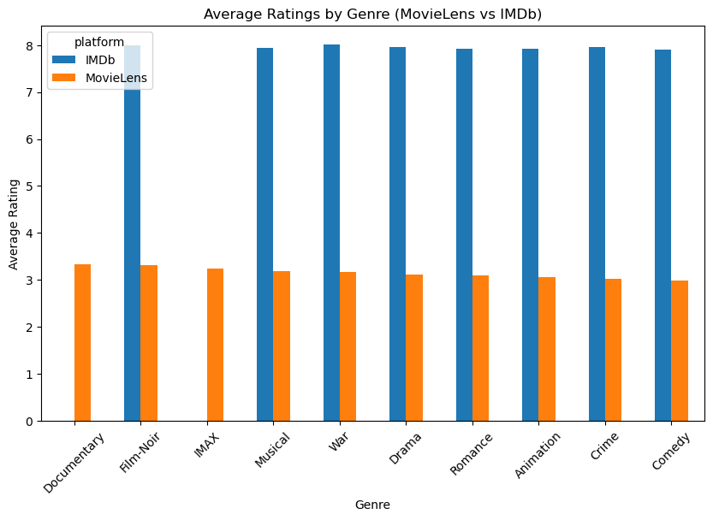
Ratings Analysis
The ratings analysis highlights important differences between MovieLens and IMDb. In the MovieLens dataset, the highest-rated genres include Documentary, Film-Noir, and IMAX, with average ratings slightly above 3.2. Other strong genres such as Musical, War, and Drama also perform well. In contrast, IMDb ratings are significantly higher overall, with top genres such as War, Western, and Film-Noir receiving ratings around 8.0. This reflects IMDb’s focus on highly rated and critically acclaimed films. While both platforms agree on certain high-quality genres such as Drama, Crime, and Film-Noir, MovieLens shows more variation due to broader user participation, whereas IMDb ratings are more consistent and concentrated.
Release Trends Analysis
The analysis of content production over time reveals significant differences across platforms. MovieLens shows a steady increase in the number of titles over time, reflecting the expansion of film production and broad dataset coverage. Netflix displays rapid growth in recent years, with a sharp increase in content starting in the 2000s and peaking in the late 2010s. This trend reflects the rise of streaming platforms and increased production of digital content. IMDb shows a more stable and gradual trend, indicating a curated selection of notable films rather than large-scale content volume. Overall, the results highlight the shift in the entertainment industry from traditional film production to modern streaming platforms.
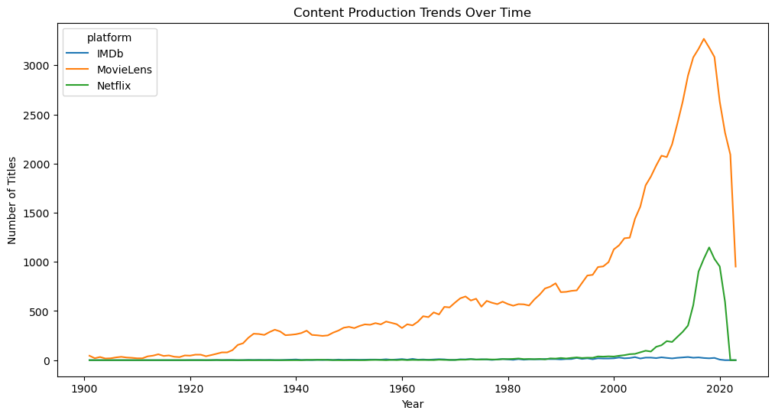
Conclusion
This project provided a comprehensive analysis of entertainment industry trends by combining data from MovieLens, Netflix, and IMDb. The results demonstrate clear differences in genre distribution, ratings, and content production across platforms. MovieLens reflects a broad range of user preferences, IMDb emphasizes critically acclaimed content, and Netflix represents modern streaming trends with a focus on recent releases. Together, these datasets illustrate how the entertainment industry has evolved over time. This analysis highlights the value of combining multiple data sources to gain deeper insights into real-world trends and audience behavior.

